Features
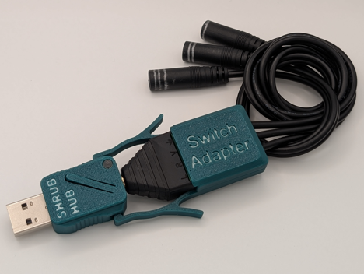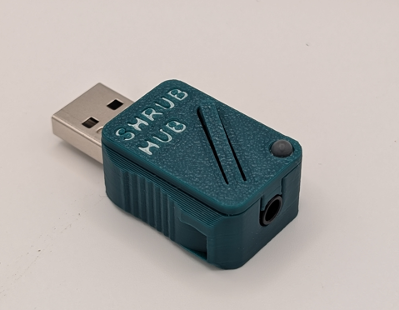
Mode Indicator
3-1 Switch Adapter
USB Connector
Switch Input Ports
Reset Button
Mode Indicator
USB Connector
Switch Input Jack
Reset Button
Operating Mode in Single Switch Mode
Input |  | Output
Activation | Input Switch | Mode 1  (Teal) | Mode 2 (Purple) | Mode 3 (Yellow) | Mode 4 (Green) | Mode 5  (Orange)
One Switch | Switch 1 | Enter | F1 | Left Click | F13 | Play/Pause

Operating Mode in Multiple Switch Mode
Input |  | Output
Activation | Input Switch | Mode 1  (Teal) | Mode 2 (Purple) | Mode 3 (Yellow) | Mode 4 (Green) | Mode 5  (Orange)
One Switch | Switch 1 | Enter | F1 | Left Click | F13 | Play/Pause
 | Switch 2 | Space | F2 | Right Click | F14 | Volume Up
 | Switch 3 | Tab | F3 | Middle Click | F15 | Volume Down
Two Switch | Switch 1+2 | Backspace | F4 | Left Click | F16 | Next Track
 | Switch 2+3 | Escape | F5 | Right Click | F17 | Previous Track
 | Switch 1+3 | Enter | F1 | Left Click | F13 | Play/Pause
Three Switch | Switch 1+2+3 | Enter | F1 | Left Click | F13 | Play/Pause

The operating mode can be changed by performing a long press (holding for longer than four seconds) on any connected switch.

Setup

Single Switch Configuration
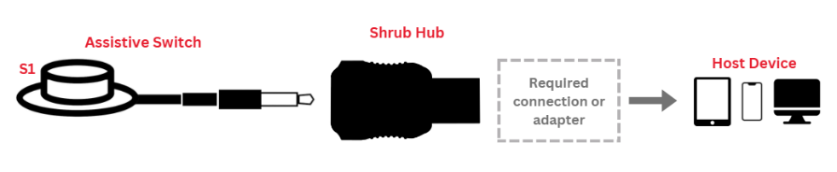

1-3 Switches
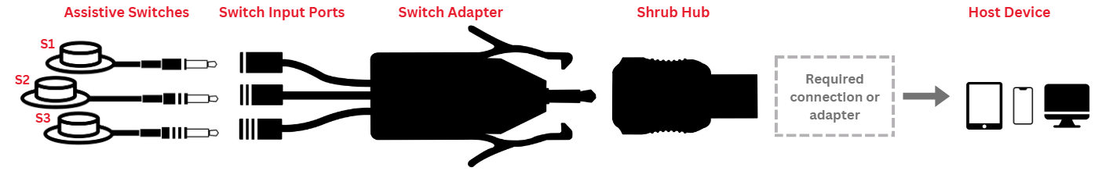

If the connected device does not have a USB-A port, an adapter will be needed. If used with an iOS device, it will need a separate power source as described in the iOS use section.

Further Information
If you are looking for information on troubleshooting, support, or any other questions, refer to the User Guide. | User Guide

